**Final Project**

This Project is made by Abdul Rehman Lashari and Arslan. We are the Students of IBA Community College Naushahro Feroze. This project is a Flight Reservation System.

This Application is really helpful in companies that manages the flights. It provides an easy way to manage the customers, tickets and Flights. This Application also prevents unauthorized uses by username and id as the company’s information don’t get leaked.

**Flight Reservation System**

Following are the function of Application.

Login Form

Customer Menu.

Flight Menu

Ticket Menu

User Menu

**Login Form.**

First of all when you run the application. A login interface appears you have to Login with username and password. Default username and password we have set is admin and admin.

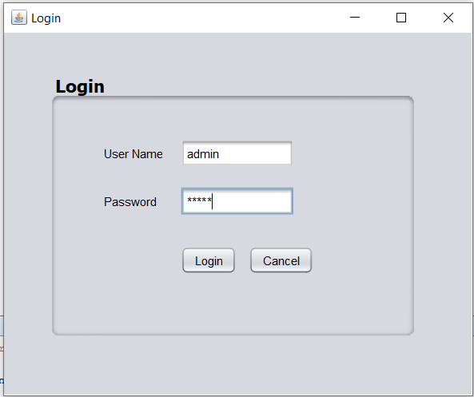

You need to login and then you can create new user that will be shown below in this document.

Once you Login you’ll get an interface like this.

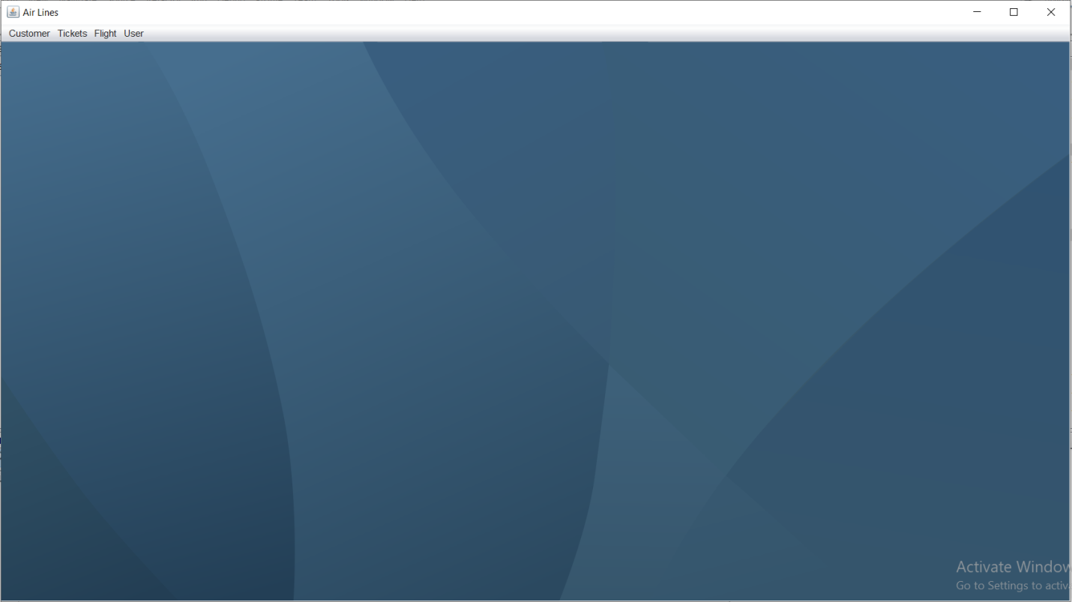

**Customer Menu.**

**Add Customer:**

As we know that this is Flight Reservation System Project so we need to add the customers to our database so to add the customers just click on customer menu and then click on add customer.

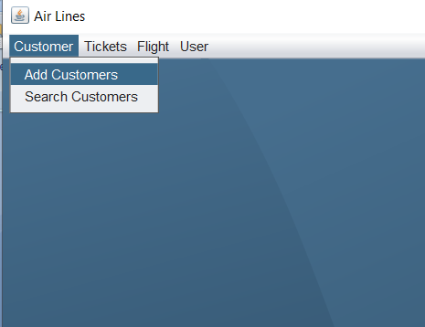

Once you clicked the Add customer then you’ll get interface like this.

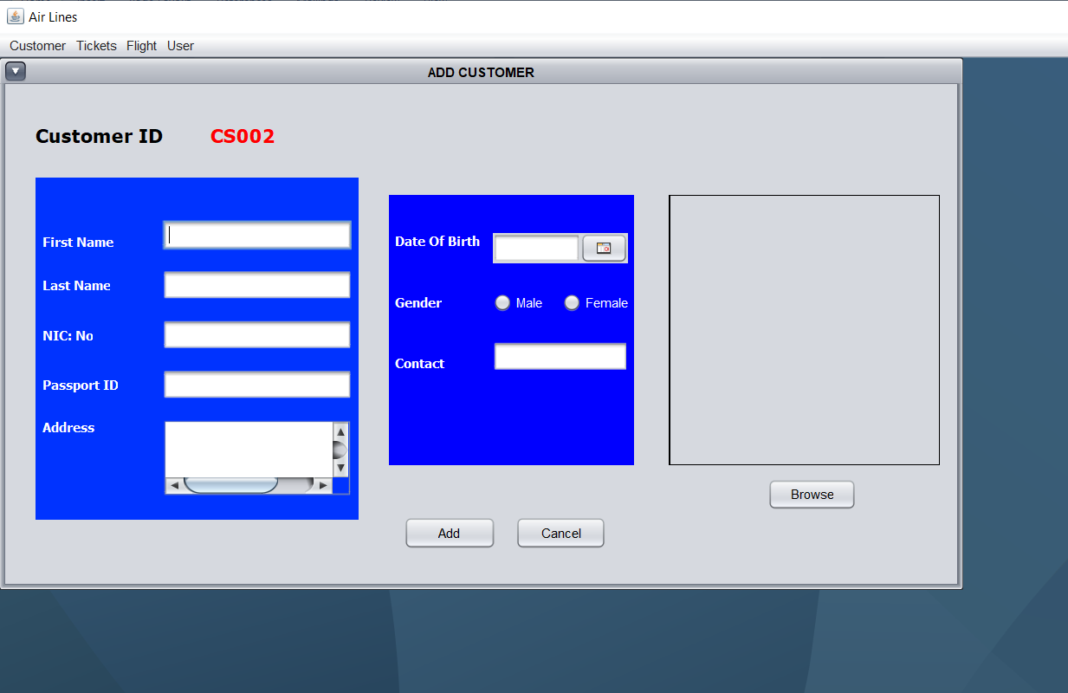

Here you need to enter the customer details and then hit “Add” button. Remember that the customer id is auto generated.

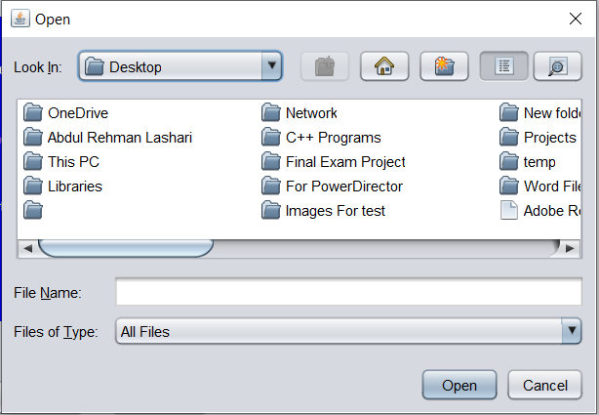

To enter the picture of company’s customers this application also provide a little window to browse the picture and this window appears when you click to “browse” button.

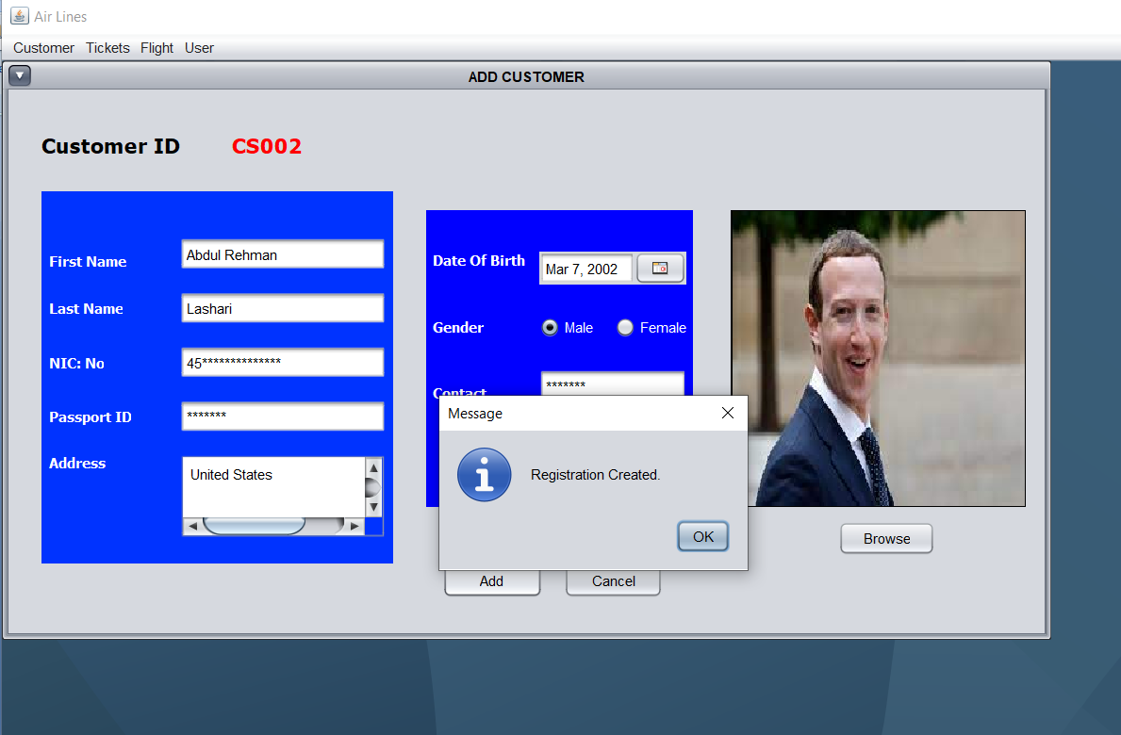

Enter all the details and then when you hit “Add” then you should get message like “Registration Created.”

**Search Customer:**

Now to search customer go to customer menu and select search customer.

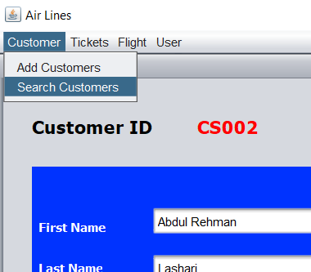

When you select this one. You’ll get window like this.

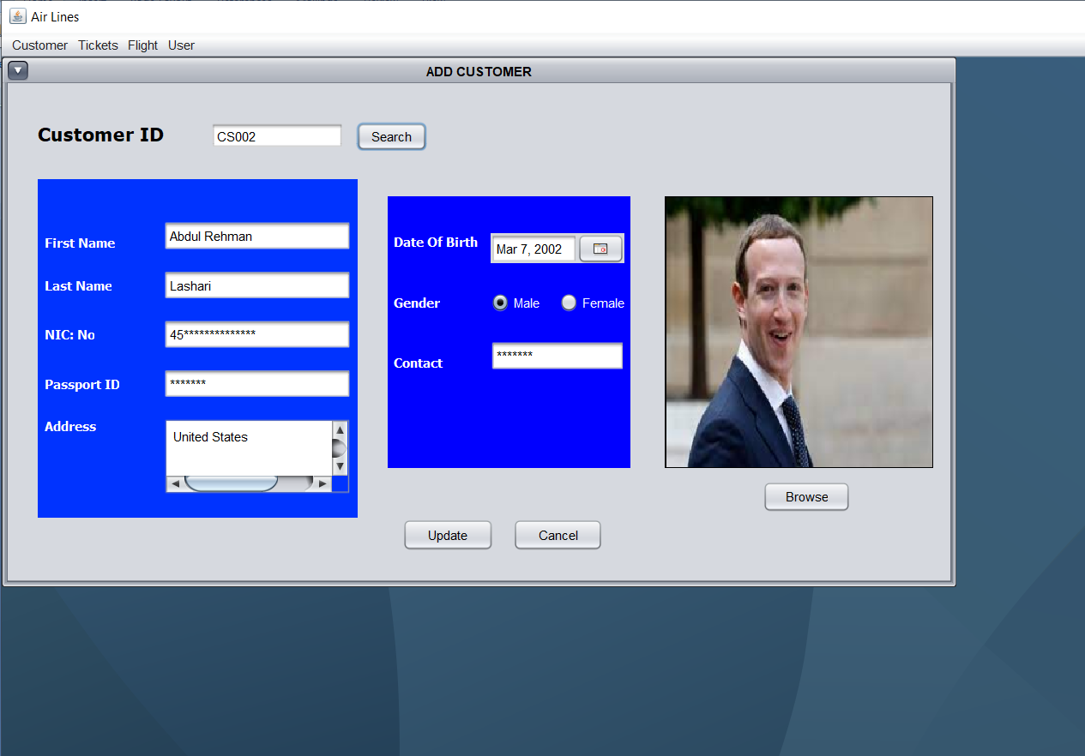

In this window you just need to enter the customer id and everything else will be filled automatically.

You can also update the information from here.

**Flight Menu**

In Flight Menu you will be able to add the flights.

Go to flight menu and select “Add Flight”.

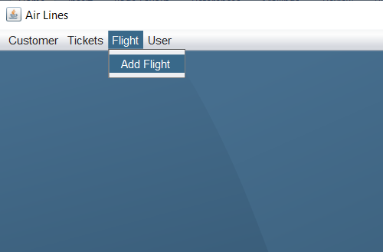

Once you selected add flight you’ll get interface like this.

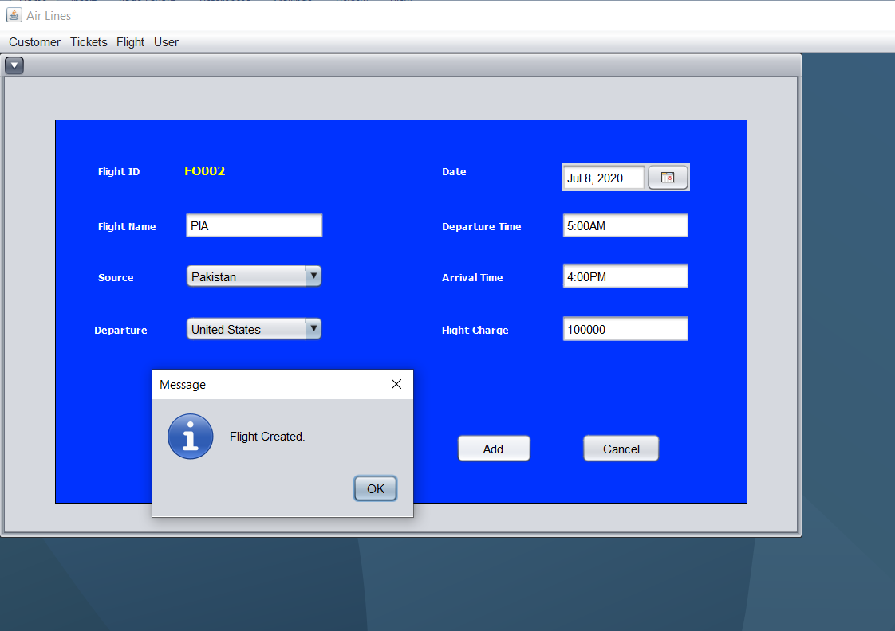

You need to enter the information of the flight and then hid “Add” button. Then you should see the message that “Flight Created”. Now you flight has been added.

Notice that the Flight id is also auto generated.

Note: Flight id consists of five letters from which first one is “F” second one is “O” (it’s not zero as it looks like.) and the remaining three are numbers.

**Ticket Menu**

In ticket menu there are two option one is ticket book where you can book ticket and second one is ticket report where you’ll be able to see the report of all tickets.

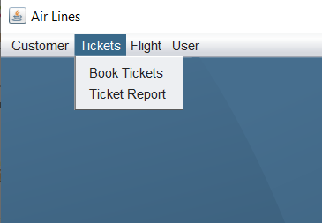

**Ticket Book.**

If you select the “Book Tickets” then interface will be like this.

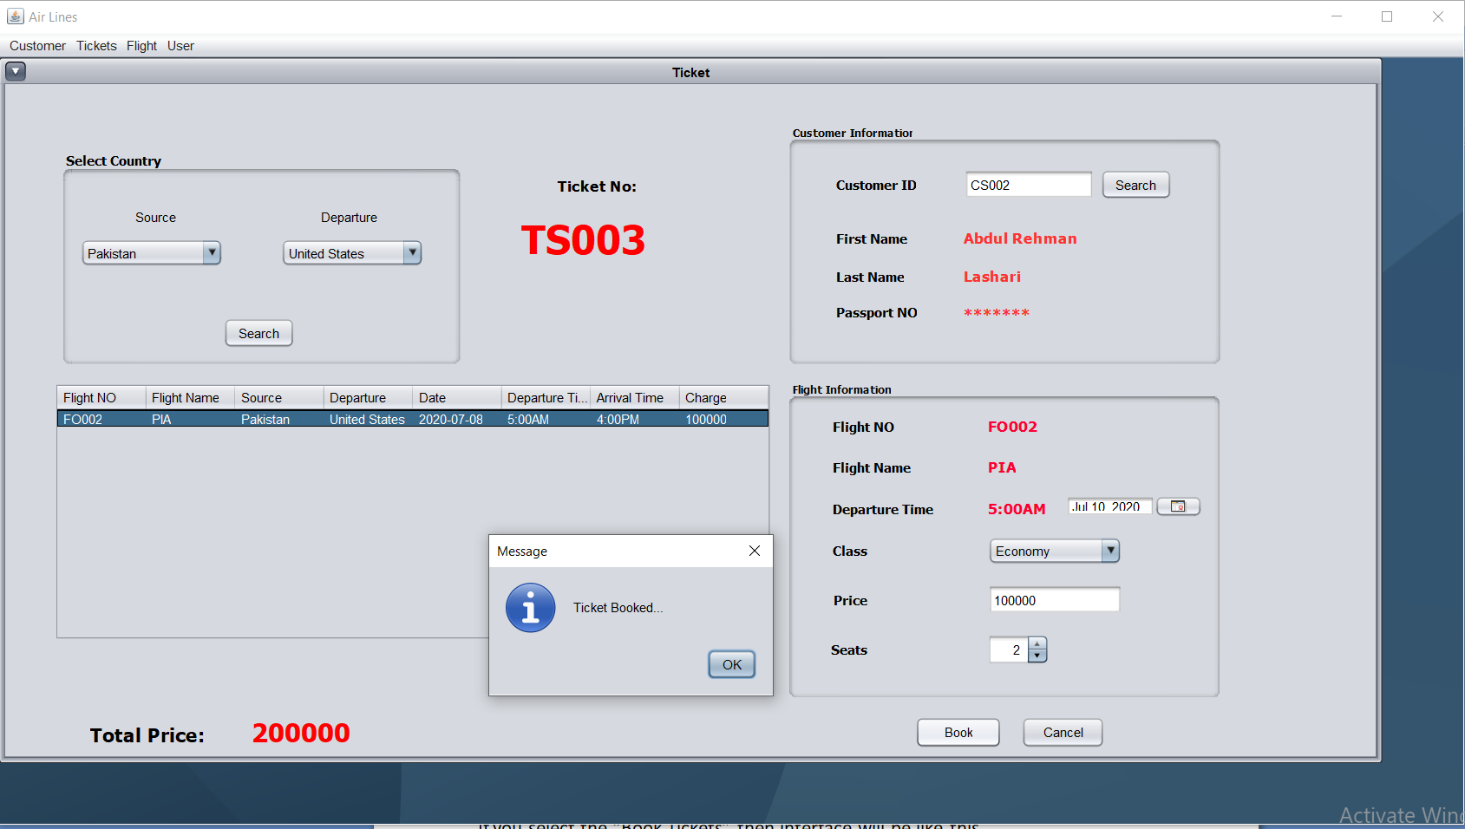

In this window you see a panel named as select country.

Just select countries and the corresponding flights will be auto shown in table.

Just select the flight you want to go and the flight information will automatically be filled in Flight Information panel.

In Customer Information panel you just need to enter the id of the customer and remaining details of the customer will be automatically filled.

Ticket ID is auto generated.

Once every thing is done then hit button “Book” and you’ll get message “Ticket Booked.”.

Now your ticket is booked.

**Ticket Report.**

In ticket report there is a table which shows all the tickets and their information.

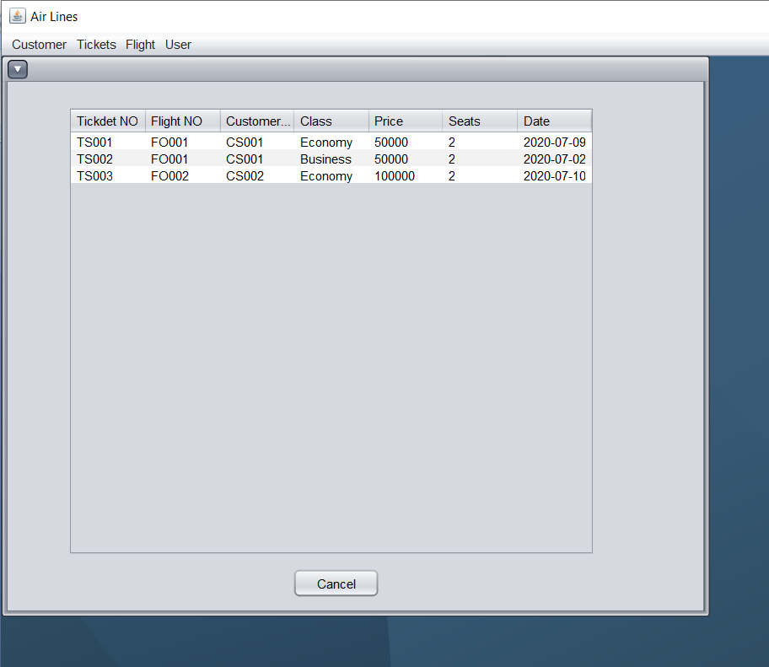

**User Menu**

In user menu you’ll be able to create the new users.

Go to user menu and select “user creation”.

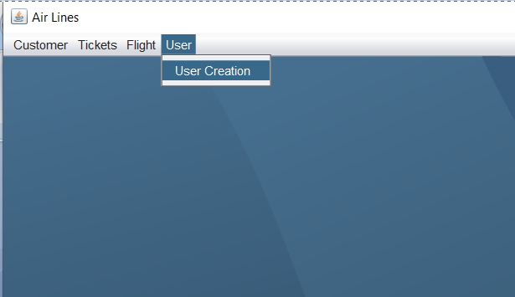

Once you select that.

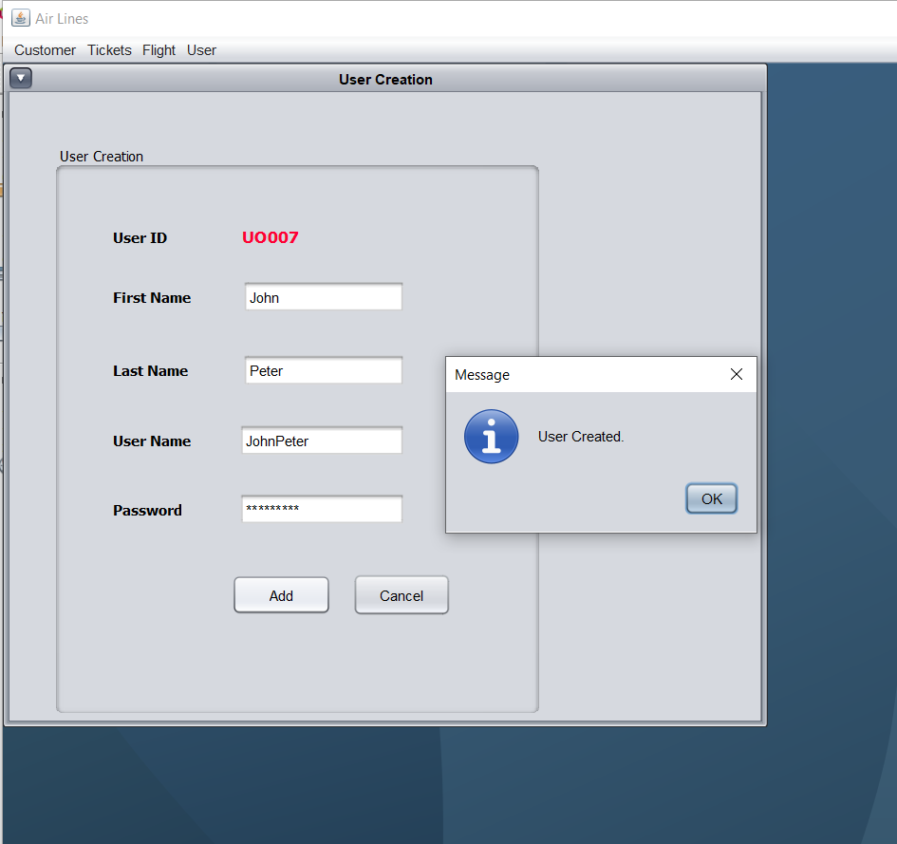

In this window you need to enter you information and then hit “Add” button and new User will be created.

User ID is auto generated. (First two letters in ID are alphabet and remaining three are numbers).

**Learning Outcomes**

By making this application we have learned new things just like how to browse a picture. We’ve just had a good practice of database management. We’ve learned how to work in team. When you go to make whole application by yourself then you don’t need to worry about external programs and you go just in you flow but in team work you also need to make room for your partner’s program.

Mostly Programs gets stopped because of your partner doesn’t handle exception or you don’t so you need to manage all that stuff.

In a nutshell this project was a really good team work experience.